Data Flow Diagram & User Stories
Date | 26 September 2026
Team ID | SWTID-2026-1610
Project Name | AI Study Buddy
Maximum Marks | 4 Marks

1. Data Flow Diagram (DFD)
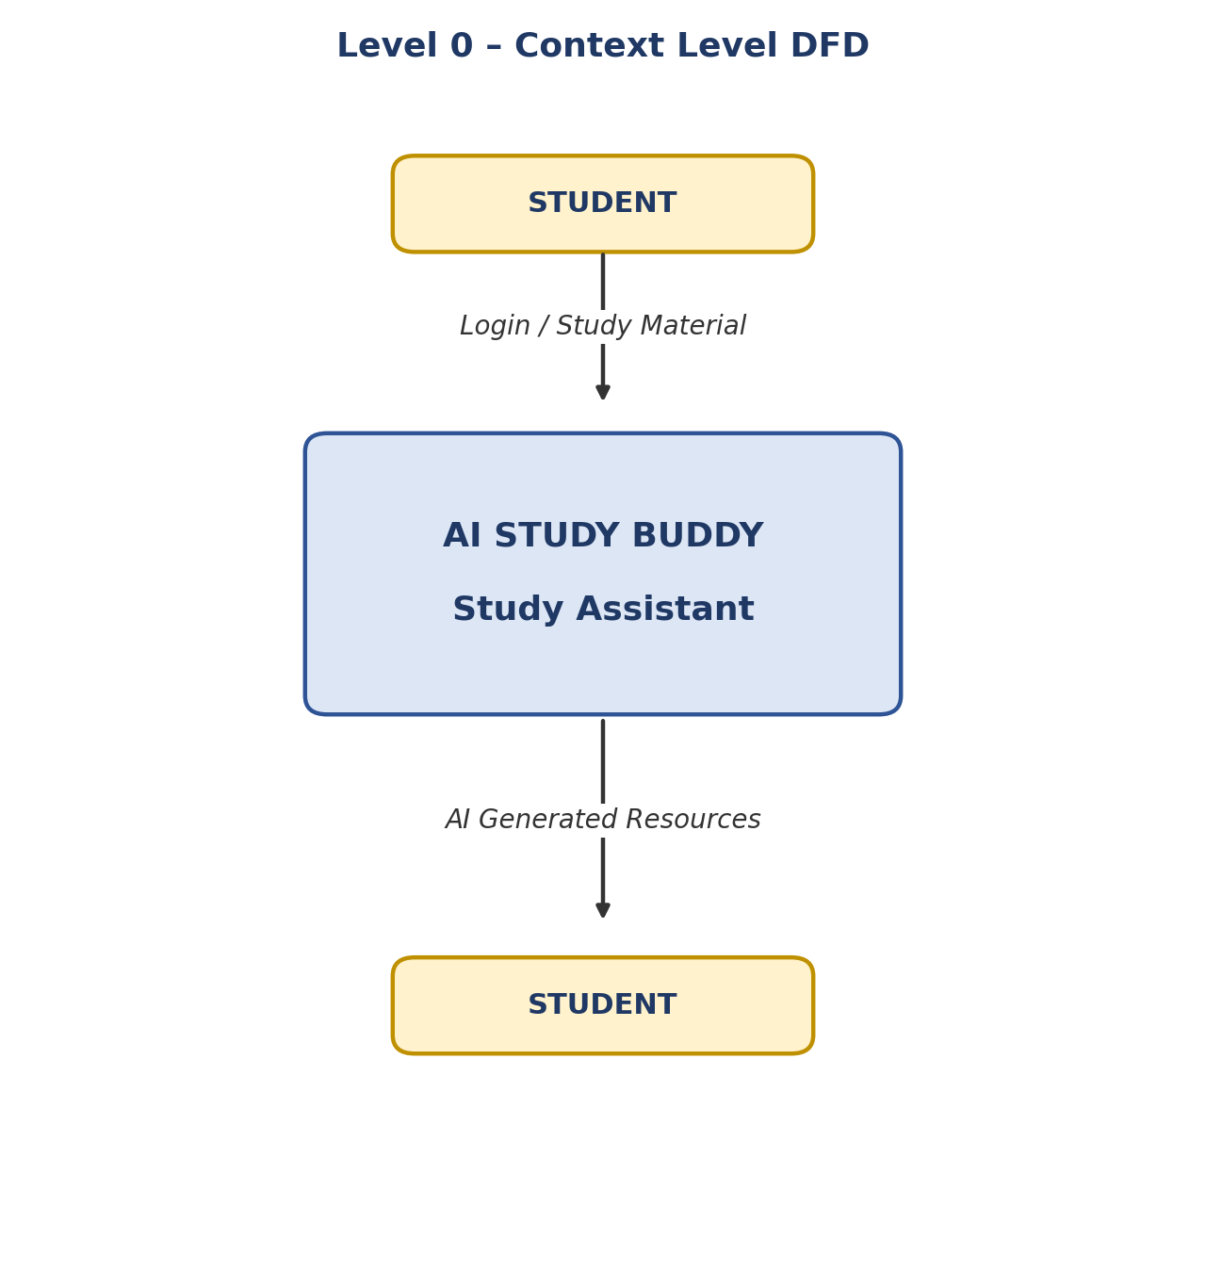

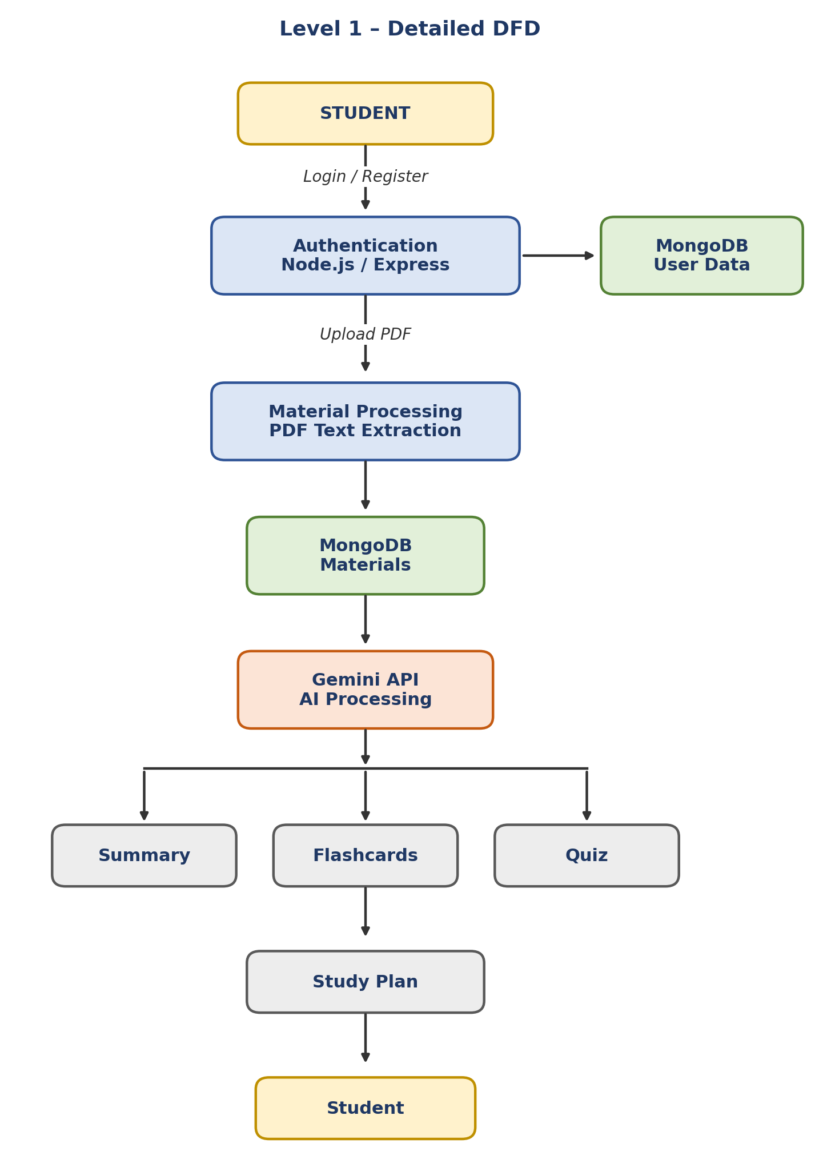

DFD Description
The student first registers or logs into the AI Study Buddy system. Authentication is handled by the Node.js and Express.js backend.
After authentication, the student can upload study materials in PDF format. The system extracts the text from the uploaded material and stores the required information in MongoDB.
The extracted study content is processed using the Google Gemini API. Based on the uploaded material, the system generates summaries, flashcards, quizzes, and personalized study plans. The generated results are then provided to the student.

2. User Stories
User Type | Functional Requirement (Epic) | User Story Number | User Story / Task | Acceptance Criteria | Priority | Release
Student | Registration | USN-1 | As a student, I can register for the application by providing my required account details. | Student details are stored successfully and the student can use the account to log in. | High | Sprint-1
Student | Login | USN-2 | As a student, I can log into the application using my registered credentials. | Valid credentials allow access and an authentication token is generated. | High | Sprint-1
Student | Authentication | USN-3 | As a student, I can access protected features only after authentication. | Valid JWT token allows access to protected APIs. | High | Sprint-1
Student | Study Material Upload | USN-4 | As a student, I can upload my study material in PDF format. | PDF is uploaded successfully and material information is stored. | High | Sprint-1
Student | Material Processing | USN-5 | As a student, I can upload study material and have its text extracted by the system. | Text is extracted successfully from the uploaded PDF. | High | Sprint-1
Student | AI Summary | USN-6 | As a student, I can generate a summary from my uploaded study material. | The system generates and returns a summary using AI. | High | Sprint-2
Student | AI Flashcards | USN-7 | As a student, I can generate flashcards from my study material for revision. | The system generates question-and-answer flashcards. | High | Sprint-2
Student | AI Quiz | USN-8 | As a student, I can generate a quiz from my uploaded study material. | The system generates multiple-choice questions with answers. | High | Sprint-2
Student | Study Plan | USN-9 | As a student, I can generate a personalized study plan based on my goal, available hours, and number of days. | The system generates a study plan based on the provided inputs. | High | Sprint-2

User Story Summary
The AI Study Buddy user stories focus mainly on the student because the student is the primary user of the system.
The main user journey is:
Register → Login → Upload Study Material → Extract Content → Generate Summary / Flashcards / Quiz / Study Plan → Use the Generated Learning Resources

Priority
High: Core features required for the project.
Medium: Features that can be considered for future development.
Low: Features outside the current project scope.

Release Plan
Sprint-1: Authentication, PDF upload and material processing.
Sprint-2: AI Summary, Flashcards, Quiz and Personalized Study Plan.

